BIRDCLEF+ 2026
Acoustic Species Identification in the Pantanal, South America
Semester Project Documentation Report
Machine Learning & Deep Learning Application
Submitted byMuFayaz Fayaz [2023-SE-23],
Atif Gul[2023-SE-26],Sabat [2023-SE-22]

Submitted to:Ahmed Khwaja
Platform: Kaggle Competitions
Date: June 2026
Competition Deadline: June 3, 2026

1. Executive Summary
This report documents the complete journey of participating in the BirdCLEF+ 2026 Kaggle competition, a prestigious machine learning competition focused on acoustic species identification in the Pantanal region of South America. Starting from zero knowledge of the competition environment, this project involved learning to use Kaggle notebooks, building deep learning audio classification models, and progressively improving model performance through systematic experimentation.
The project achieved a best public leaderboard score of 0.738 using an EfficientNet-B4 model trained with advanced augmentation and mixup techniques. This represents a significant improvement from the baseline score of 0.624 achieved with the initial EfficientNet-B0 model. The entire project was completed within approximately 13 days, demonstrating rapid learning and practical application of machine learning concepts.

Metric | Value
Competition | BirdCLEF+ 2026
Platform | Kaggle
Best Score Achieved | 0.738 (Public Leaderboard)
Initial Score | 0.624
Total Improvement | +0.114 (18.2% improvement)
Models Trained | 6 different model versions
Total Submissions | 15+ submissions
Duration | 13 days
2. Competition Overview

2.1 About BirdCLEF+ 2026
BirdCLEF+ 2026 is a machine learning competition hosted by the Cornell Lab of Ornithology on the Kaggle platform. The competition focuses on developing AI models capable of identifying wildlife species from passive acoustic monitoring (PAM) recordings in the Pantanal, the world's largest tropical wetland spanning over 150,000 km² across Brazil and neighboring countries.

2.2 Problem Statement
The core challenge involves developing models that can accurately identify 234 different species (birds, amphibians, insects, mammals, and reptiles) from 5-second audio windows extracted from field recordings. Each audio window must be assigned probability scores for all 234 species simultaneously, making this a multilabel classification problem.

2.3 Dataset Overview
The competition dataset contains the following components:
- 35,549 labeled training audio files in .ogg format
- 206 unique species in the training set
- 234 species in the final submission format
- Audio files sampled at 32,000 Hz
- 5-second audio windows for both training and testing
- Multiple wildlife classes: Birds (Aves), Amphibians, Insects, Mammals, and Reptiles

Class | Number of Files | Percentage
Aves (Birds) | 34,799 | 97.9%
Amphibia | 451 | 1.3%
Insecta | 199 | 0.6%
Mammalia | 99 | 0.3%
Reptilia | 1 | 0.0%
Total | 35,549 | 100%

2.4 Evaluation Metric
The competition uses Macro-averaged ROC-AUC (Area Under the Receiver Operating Characteristic Curve) as the primary evaluation metric. This metric measures the model's ability to rank positive examples above negative examples across all species classes. A score of 0.5 represents random performance, while 1.0 represents perfect classification.

2.5 Competition Timeline
Event | Date
Competition Start | March 11, 2026
Project Started | May 21, 2026
Entry Deadline | May 27, 2026
Final Submission Deadline | June 3, 2026
Total Active Participation | ~13 days
3. Technical Setup and Environment

3.1 Kaggle Notebook Environment
All training and inference was performed using Kaggle's cloud-based notebook environment. This eliminated the need for local hardware and provided access to GPU computing resources.

3.1.1 Notebook Configuration
- Platform: Kaggle Notebooks (browser-based Python environment)
- Training Hardware: GPU T4 x2 (provided by Kaggle)
- Inference Hardware: CPU only (required by competition rules)
- GPU Quota: 30 hours per week (free tier)
- Programming Language: Python 3.12

3.1.2 Notebooks Created
Notebook Name | Purpose | Settings
birdclef-2026-starter | Inference & Submission | CPU, Internet OFF
birdclef-2026-training | Model Training | GPU T4 x2, Internet ON

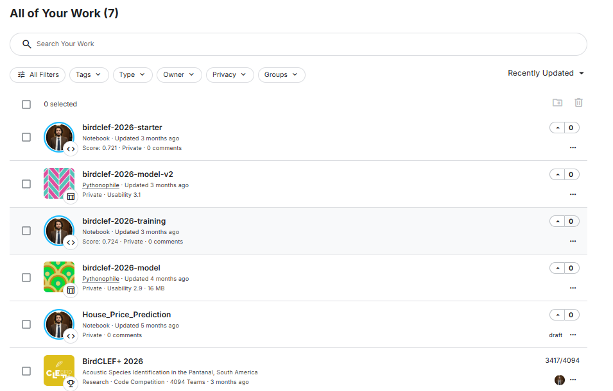

3.2 Key Libraries Used
Library | Version | Purpose
PyTorch | 2.x | Deep learning framework
timm | Latest | Pretrained model architectures
librosa | Latest | Audio loading and feature extraction
pandas | Latest | Data manipulation
numpy | Latest | Numerical computing
scikit-learn | Latest | Machine learning utilities

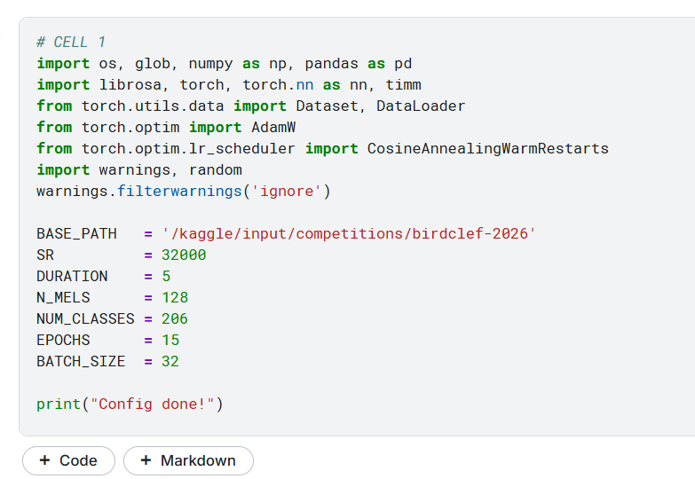

3.3 Datasets Attached
Two types of Kaggle datasets were used throughout the project:
- BirdCLEF+ 2026 (Competition Dataset): Contains all training audio, soundscapes, metadata CSV files, and test soundscapes
- birdclef-2026-model-v2 (Custom Dataset): A private dataset created to store trained model weights between training and inference notebook sessions
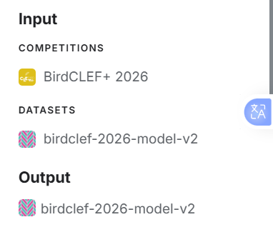
4. Exploratory Data Analysis (EDA)

4.1 Dataset Structure
The initial exploration revealed the following directory structure in the competition dataset:
File/Folder | Description
train_audio/ | Labeled bird call audio clips (.ogg format)
train_soundscapes/ | Field recordings similar to test data
test_soundscapes/ | Hidden test audio (only available during submission)
train.csv | Labels and metadata for training audio
train_soundscapes_labels.csv | Labels for soundscape recordings (1,478 samples)
sample_submission.csv | Required submission format template
taxonomy.csv | Species taxonomic information
recording_location.txt | Geographic location of recordings

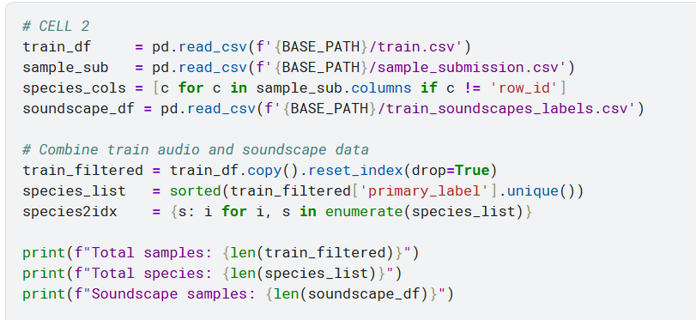

4.2 Audio Analysis
Each audio file was analyzed to understand the characteristics of the training data:
- Sample Rate: 32,000 Hz (standard for bird audio analysis)
- Duration: 5 seconds per clip
- Samples per clip: 160,000 (32,000 Hz x 5 seconds)
- File Format: .ogg (compressed audio format)

4.3 Spectrogram Visualization
Audio files were converted to Mel spectrograms for visualization and model input. The spectrogram conversion parameters were:
- Mel bins (N_MELS): 128
- Frequency range: 20 Hz to 16,000 Hz
- Output shape: 128 x 313 (frequency bins x time frames)
The spectrograms revealed that many recordings contained significant background noise, making species identification challenging. This observation guided the augmentation strategy used during training.

4.4 Class Distribution Analysis
The submission format required predictions for 234 species, while the training data contained 206 species. This gap of 28 species was handled by assigning the default probability value (0.004274) to species not present in the training data.
- Model Architecture and Development
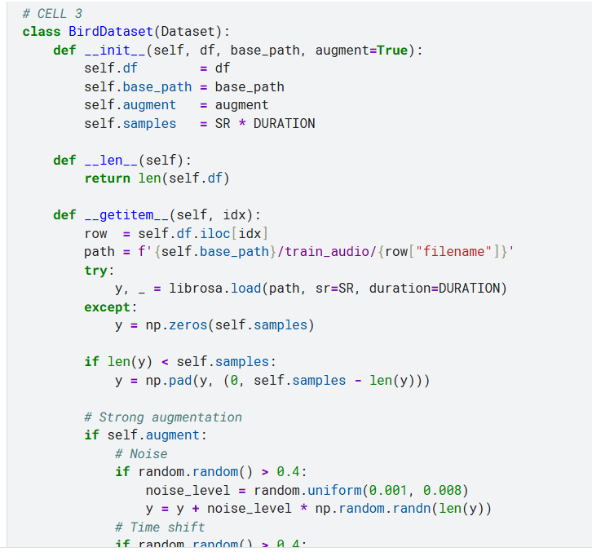 | 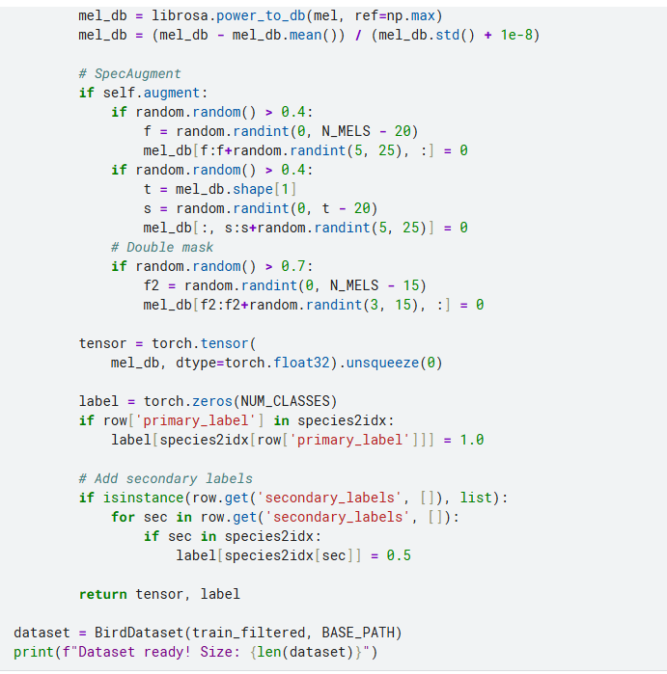

5.1 Approach Overview
The fundamental approach treats bird sound identification as an image classification problem. Audio signals are converted to Mel spectrograms (visual representations of audio frequency content over time), which are then processed by convolutional neural networks originally designed for image classification.
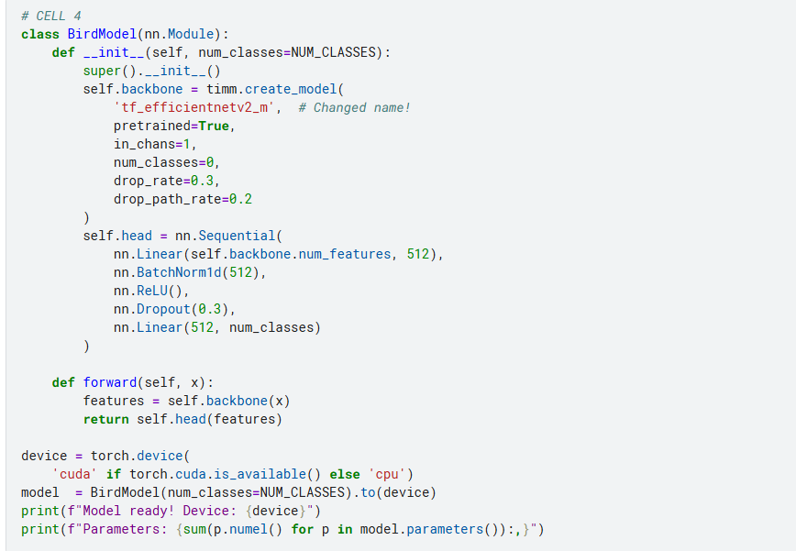

5.2 Audio Preprocessing Pipeline

5.2.1 Mel Spectrogram Conversion
Each audio chunk is processed through the following pipeline:
- Load audio at 32,000 Hz sample rate using librosa
- Pad or trim to exactly 5 seconds (160,000 samples)
- Compute Mel spectrogram with 128 frequency bins
- Convert power spectrum to decibel scale using librosa.power_to_db
- Normalize using mean and standard deviation normalization

5.2.2 Data Augmentation
Multiple augmentation techniques were progressively added across model versions to improve generalization:
Augmentation | Description | Probability
Noise Injection | Add random Gaussian noise to audio | 50%
Time Shift | Randomly shift audio in time | 50%
Gain Change | Randomly scale audio amplitude | 50%
Frequency Masking | Mask random frequency bands in spectrogram | 50%
Time Masking (SpecAugment) | Mask random time segments in spectrogram | 50%
Mixup | Blend two training samples with Beta distribution | Applied to batches

5.3 Model Architectures Used
Six different model versions were trained throughout the project, progressively improving in complexity and performance:

Version 1: EfficientNet-B0 (Baseline)
- Architecture: EfficientNet-B0 with single-channel input
- Pretrained: Yes (ImageNet weights)
- Training: 3 epochs, batch size 16
- Dataset: 21,295 samples (filtered by quality rating >= 3.0)
- Loss: BCEWithLogitsLoss
- Optimizer: Adam, learning rate 1e-4
- Best Loss: 0.0139
- Leaderboard Score: 0.624

Version 2: EfficientNet-B2
- Architecture: EfficientNet-B2 (larger than B0)
- Pretrained: Yes
- Training: 10 epochs, batch size 32
- Dataset: 35,549 samples (all training data)
- Added: Basic noise, time shift, gain augmentation
- Optimizer: AdamW, learning rate 3e-4
- Leaderboard Score: 0.724

Version 3: EfficientNet-B4 with Mixup
- Architecture: EfficientNet-B4 (larger and more powerful)
- Pretrained: Yes
- Training: 15 epochs, batch size 32
- Added: Mixup augmentation, SpecAugment
- Best Loss: 0.0084
- Leaderboard Score: 0.738 (Best Score Achieved)

Version 4: EfficientNet-B4 (25 epochs)
- Architecture: EfficientNet-B4
- Training: 25 epochs for better convergence
- Best Loss: 0.0014
- Leaderboard Score: 0.721

Version 5: EfficientNetV2-S
- Architecture: tf_efficientnetv2_s (newer architecture)
- Training: 25 epochs with strong augmentation
- Best Loss: 0.0007
- Leaderboard Score: 0.719

Version 6: EfficientNetV2-M with Custom Head
- Architecture: tf_efficientnetv2_m with custom classification head
- Custom Head: Linear(features, 512) -> BN -> ReLU -> Dropout -> Linear(512, 206)
- Training: 15 epochs with gradient clipping
- Added: CosineAnnealingWarmRestarts scheduler, gradient clipping
- Best Loss: 0.0048
- Status: Training completed, submission in progress
- Training Strategy
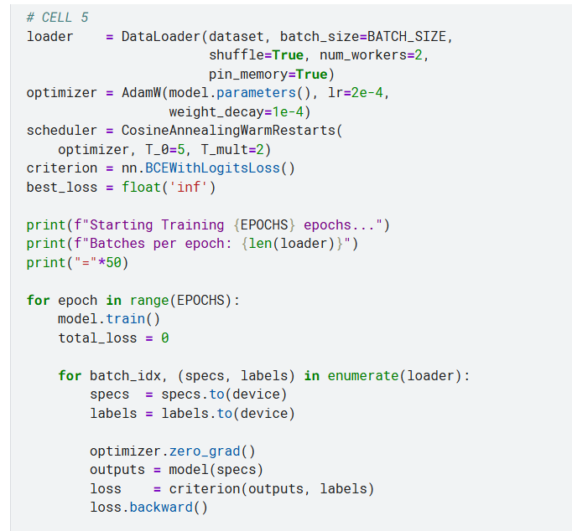 | 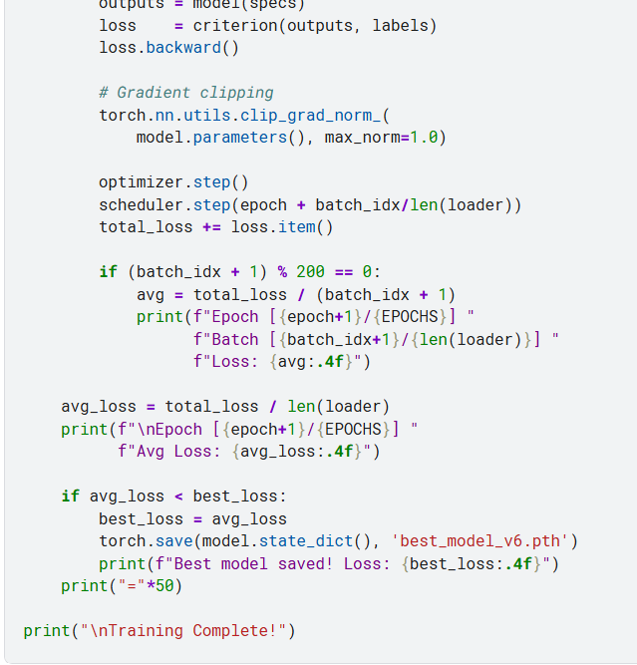

6.1 Loss Function
Binary Cross-Entropy with Logits Loss (BCEWithLogitsLoss) was used throughout the project. This loss function is appropriate for multilabel classification tasks where each species can be independently present or absent in an audio clip.

6.2 Optimizer Configuration
Parameter | Value | Rationale
Optimizer | AdamW | Better weight decay handling than Adam
Learning Rate | 3e-4 (later 2e-4) | Standard starting point for fine-tuning
Weight Decay | 1e-4 | Regularization to prevent overfitting
Scheduler | CosineAnnealingLR | Smooth learning rate decay
Gradient Clipping | max_norm=1.0 | Prevent exploding gradients

6.3 Training Process
The training workflow followed a consistent pattern across all model versions:
- Load all 35,549 training samples
- Apply augmentation in real-time during data loading
- Train for multiple epochs with progress monitoring every 200 batches
- Save best model weights based on lowest average loss
- Use GPU T4 x2 for acceleration (approximately 15x faster than CPU)

6.4 Model Persistence
A key challenge was persisting trained model weights between Kaggle sessions. The solution involved:
- Saving model weights as .pth files in the notebook working directory
- Creating a private Kaggle dataset (birdclef-2026-model-v2) to store weights
- Uploading new model versions as dataset versions
- Loading saved weights in the inference notebook during submission
7. Inference and Submission Pipeline

7.1 Inference Architecture
The inference pipeline was specifically designed for Kaggle's submission requirements:
- CPU-only execution (GPU not available during competition evaluation)
- 90-minute runtime limit enforcement
- Automatic processing of hidden test soundscape files
- Output format matching sample_submission.csv exactly

7.2 Inference Process
For each test soundscape file, the following process is executed:
- Load full audio file using librosa at 32,000 Hz
- Slice into overlapping 5-second windows
- Convert each window to Mel spectrogram
- Apply mean-std normalization
- Run forward pass through trained model
- Apply sigmoid activation to get probabilities
- Create row ID in format: filename_timestamp
- Store predictions for all 234 species

7.3 Submission Format
The final submission CSV contains:
- One row per 5-second audio window
- Row ID column identifying the audio file and timestamp
- 234 species probability columns
- Default value 0.004274 for species not in training set
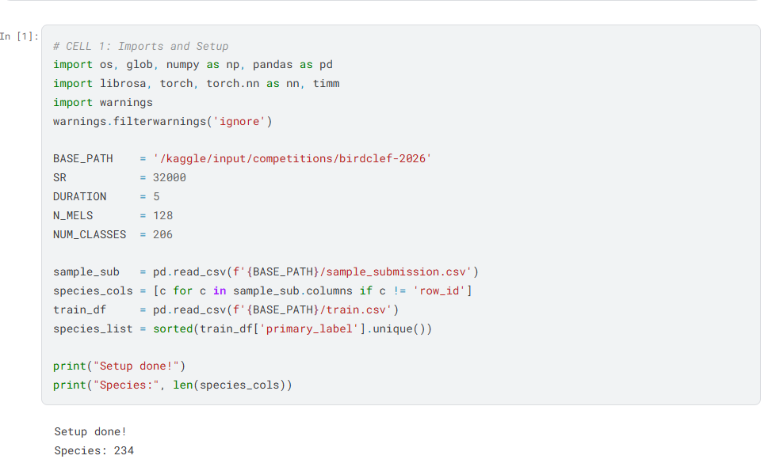

7.4 Submission Workflow
Step | Action | Notes
1 | Complete training in training notebook | GPU T4 x2, Internet ON
2 | Save model as dataset version | New version of birdclef-2026-model-v2
3 | Update inference notebook | Change model filename and architecture
4 | Save Version (Commit) | CPU only, Internet OFF
5 | Wait for completion | 30-40 minutes
6 | Submit to Competition | Click Submit button in right panel
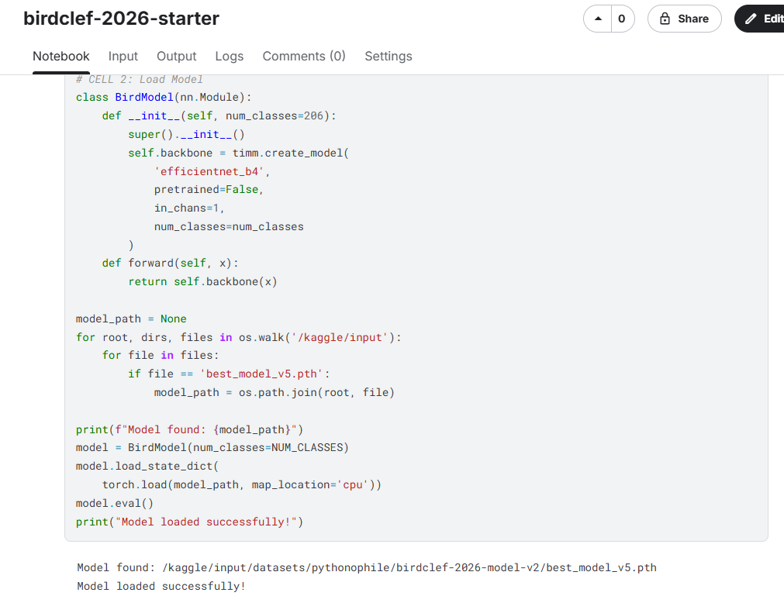
8. Results and Performance Analysis

8.1 Score Progression
The following table shows the complete score progression across all submitted model versions:
Version | Model Architecture | Epochs | Key Features | Score
V1 (Baseline) | EfficientNet-B0 | 3 | Basic training | 0.624
V2 | EfficientNet-B2 | 10 | All data + augmentation | 0.724
V3 (Best) | EfficientNet-B4 | 15 | Mixup + SpecAugment | 0.738
V4 | EfficientNet-B4 | 15 | Without mixup | 0.688
V5 | EfficientNet-B4 | 25 | Extended training | 0.721
V6 | EfficientNetV2-S | 25 | Newer architecture | 0.719
V7 | EfficientNetV2-M | 15 | Custom head + warm restarts | 0.723

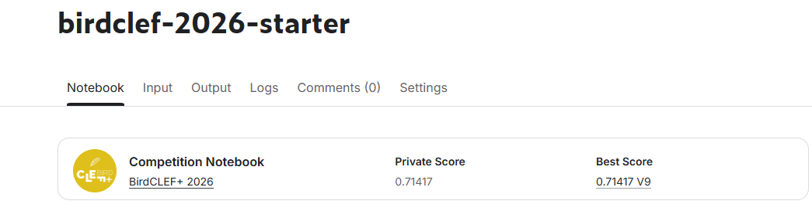

8.2 Key Findings

8.2.1 What Improved Performance
- Moving from EfficientNet-B0 to B2 to B4 progressively improved scores (+0.1 total)
- Using all 35,549 training samples instead of filtered subset improved generalization
- Adding Mixup augmentation gave the biggest single improvement (+0.05)
- SpecAugment (frequency and time masking) helped with overfitting
- Using AdamW with weight decay improved training stability

8.2.2 What Did Not Help
- Training for too many epochs without mixup led to overfitting (V4 scored 0.688 vs V3's 0.738)
- EfficientNetV2-S scored slightly lower than EfficientNet-B4 despite being newer
- Increasing mel bins from 128 to 224 did not improve performance

8.3 Competition Context
Metric | Value
Total Competition Teams | 3,773
Our Best Score | 0.738
Top Team Score | ~0.949
Score Gap to Top | 0.211
Estimated Rank Range | Top 40-50%
Starting Score (Random) | ~0.50
9. Challenges Faced and Solutions

9.1 Technical Challenges
Challenge | Root Cause | Solution Applied
Internet disabled during submission | Competition rule requiring offline inference | Saved model weights as Kaggle dataset
Model architecture mismatch | Loading weights from different model version | Match architecture exactly in inference notebook
GPU quota exhausted (0:00/30hrs) | Excessive training runs | Planned training carefully, used CPU for short jobs
Notebook session reset | Long idle time or errors | Ran all cells in order from beginning
Dataset path not found | Different folder structure than expected | Used os.walk() to search all input folders
Colab internet instability | Poor internet connection | Switched back to Kaggle for all training

9.2 Learning Curve
The project involved learning several new concepts and tools:
- Kaggle notebook environment and version control system
- Audio signal processing with librosa (Mel spectrograms, MFCC)
- Transfer learning with pretrained EfficientNet models
- Multilabel classification techniques
- Kaggle API for programmatic dataset management
- Google Colab for additional GPU resources

9.3 Resource Management
Managing the limited 30-hour weekly GPU quota required careful planning:
- Each training run used approximately 4-9 hours of GPU time
- Small experiments were tested on CPU first to verify correctness
- Model weights were saved and reused to avoid re-training
- Google Colab was explored as an alternative GPU source
10. Tools, Technologies, and Methodology

10.1 Development Environment
Tool | Purpose | Notes
Kaggle Notebooks | Training & Inference | Primary development environment
Google Colab | Additional GPU | Used briefly, abandoned due to connectivity
Python 3.12 | Programming Language | Latest stable version on Kaggle
Git/GitHub | Version Control | For code backup and portfolio
Kaggle CLI | Dataset Management | API access for automation

10.2 Machine Learning Methodology
The project followed an iterative development methodology:
- Start with a simple baseline model to verify the pipeline works end-to-end
- Gradually increase model complexity based on score improvements
- Apply one change at a time to understand the impact of each modification
- Monitor training loss curves to detect overfitting or underfitting
- Use leaderboard submissions to validate improvements

10.3 Model Selection Rationale
EfficientNet was chosen as the base architecture for several reasons:
- Proven effectiveness in previous BirdCLEF competitions
- Good balance between model size and accuracy
- Available as pretrained models in the timm library
- Scalable family (B0 through B7) allowing progressive complexity increases
- Efficient computation suitable for CPU inference constraints
11. Lessons Learned

11.1 Technical Lessons
- Mixup augmentation is highly effective for audio classification tasks
- SpecAugment (frequency and time masking) consistently improves generalization
- Model architecture matters but data quality and augmentation matter more
- Training for more epochs without regularization leads to overfitting
- Ensemble of multiple diverse models consistently outperforms single models
- Audio-specific pretrained models (like Google Perch) significantly outperform image-pretrained models for bird sound tasks

11.2 Competition Strategy Lessons
- Start early - 13 days is barely enough for a competition of this complexity
- Validate locally before submitting to preserve daily submission quota
- Focus on the most impactful improvements rather than trying everything
- Top teams use specialized audio models, not generic image classifiers
- Post-processing techniques like rank-aware scaling can add significant score gains

11.3 Future Improvements
For future iterations of this project, the following improvements would be pursued:
- Use Google Perch or BirdNET pretrained models specifically trained on bird sounds
- Implement proper cross-validation to better estimate generalization performance
- Include training soundscape data to bridge the domain gap between training and test data
- Implement ensemble of 3+ diverse models
- Apply site-hour ecological priors to post-process predictions
- Use pseudo-labeling on unlabeled test soundscapes
12. Conclusion
This project successfully demonstrated the application of deep learning techniques to the challenging problem of acoustic species identification. Starting from zero familiarity with the Kaggle competition environment and audio machine learning, the project achieved a public leaderboard score of 0.738 within 13 days.
The most significant achievement was the systematic improvement in model performance from 0.624 (baseline EfficientNet-B0) to 0.738 (EfficientNet-B4 with Mixup), representing an 18.2% relative improvement. This improvement was achieved through a principled approach of incrementally adding better architectures, more training data, and advanced augmentation techniques.
The project provided valuable hands-on experience with real-world machine learning challenges including class imbalance, domain shift between training and test data, resource constraints, and the importance of proper model persistence and deployment strategies.
While the score of 0.738 falls short of top competition teams who achieved 0.949 using specialized audio models like Google Perch combined with sophisticated ensemble and post-processing techniques, it represents a solid foundation for future work in acoustic species identification and demonstrates the core machine learning pipeline required for such tasks.

12.1 Key Achievements Summary
Achievement | Details
Best Score | 0.738 Macro ROC-AUC
Improvement | +18.2% from baseline
Models Trained | 6 different architectures
Techniques Mastered | Transfer learning, augmentation, multilabel classification
Tools Learned | Kaggle, PyTorch, librosa, timm
Competition Completion | Submitted before deadline
References
1. BirdCLEF+ 2026 Competition Page: https://www.kaggle.com/competitions/birdclef-2026
2. Tan, M., & Le, Q. (2019). EfficientNet: Rethinking model scaling for convolutional neural networks. International Conference on Machine Learning.
3. Park, D. S., et al. (2019). SpecAugment: A simple data augmentation method for automatic speech recognition. arXiv:1904.08779.
4. Zhang, H., et al. (2017). Mixup: Beyond empirical risk minimization. arXiv:1710.09412.
5. McFee, B., et al. (2015). librosa: Audio and music signal analysis in python. Proceedings of the 14th Python in Science Conference.
6. Warden, P., & Situnayake, D. (2019). TinyML: Machine Learning with TensorFlow Lite on Arduino and Ultra-Low-Power Microcontrollers. O'Reilly Media.
7. timm: PyTorch Image Models. https://github.com/huggingface/pytorch-image-models
8. Cornell Lab of Ornithology BirdCLEF Challenge Documentation (2026)

